**Assessment 1**

**Evaluate and communicate business requirements**

**70351 Tomohiro Matsuyama**

**My website: https://tomm66.github.io/70351ECBR/**

**Assessment – Research and Questioning**

Contents

Instructions: 1

Business Scenario 1

Task 1: Determine support areas 2

Task 2: Identify stakeholders 2

Task 3: Develop support procedures 2

Task 4: Assign Support Personnel 2

Task 5: Short Answer Questions 3

Task 6: Multiple Choice Questions 3

Search Index 8

**My website:** [**https://tomm66.github.io/70351ECBR/**](https://tomm66.github.io/70351ECBR/)

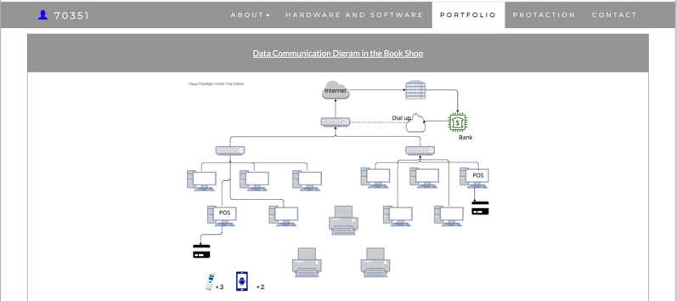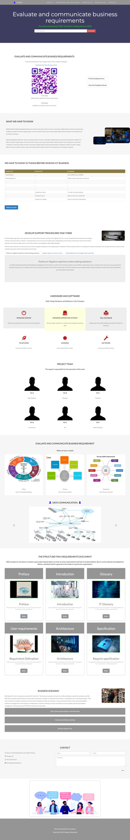

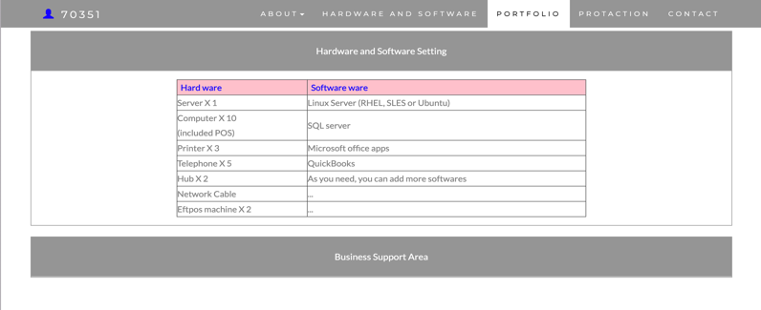

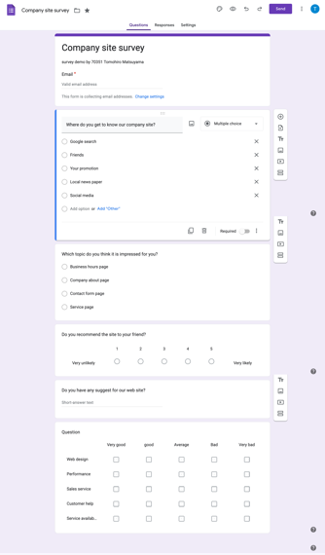

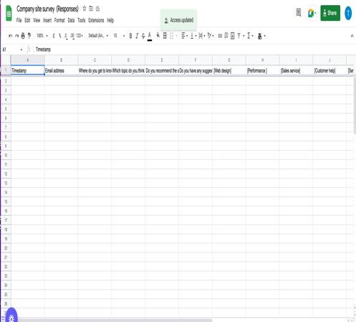

# Instructions:

This is an individual assessment. Answer all the questions on the document provided by your Trainer.

***Duration:***

Trainer will set the duration of the assessment.

# Business Scenario

D&K Books Pty Ltd is a bookstore owned by Mr. Dean Kerr. The business occupies two levels of an office building connected by escalators and lifts. D&K Books employs approximately six sales staff, one operation manager, two administrative officers, a bookkeeper and a marketing manager. They have an Ethernet network consisting of ten PCs (Intel I3 Desktop cloned), two switches, a router and three printers. They use the QuickBooks software to manage their entire business, including sales, inventory, ordering, accounts receivable, accounts payable, payroll and employee management. They also have two EFTPOS terminals one on each floor.

D&K Books has a Linux server that stores all of the data including the QuickBooks database. The server is backed up to tape regularly. They also have a website (hosted on an Australian ISP’s server, dynamic and static pages using asp.net) on which customers can browse the product catalogue and view current specials. They also lease a telephone system from Live Telecoms. The PABX (phone system) consists of a main switchboard and five remote phones with three incoming lines and a message-on-hold queue system.

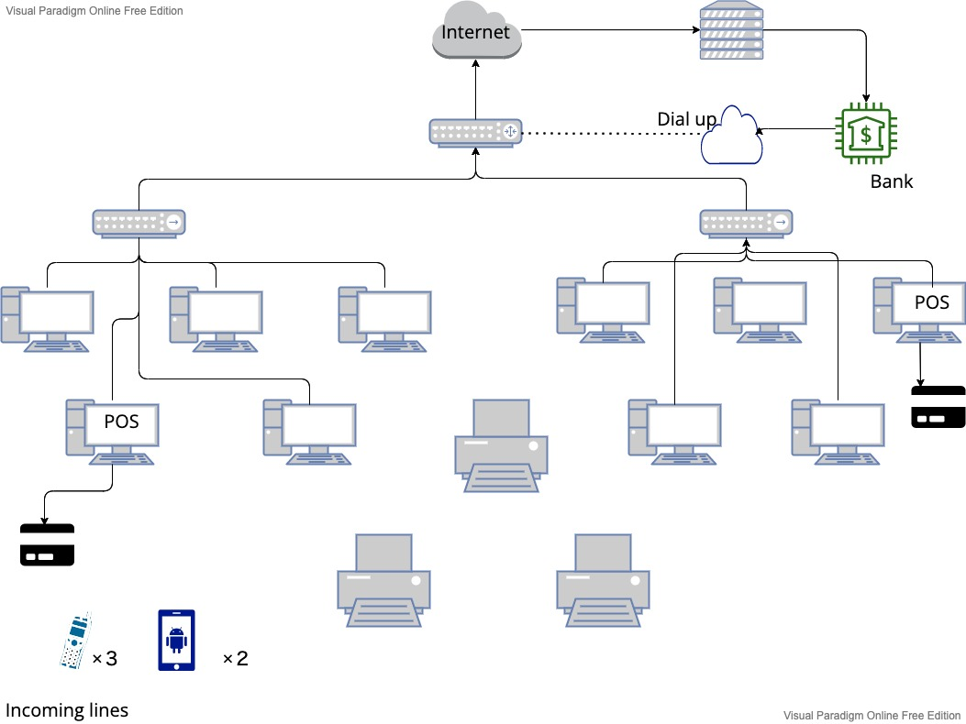

* SQL Server is supported on Red Hat Enterprise Linux (RHEL), SUSE Linux Enterprise Server (SLES), or Ubuntu.
* Eftpos is okay on Linux
* Use Microsoft Office apps on Linux
* Generally, Linux does not require antivirus
* On Linux, system-related files are owned by the “root” superuser. If infected, viruses can be easily removed as they can only affect the user account where they were installed, and they do not affect the root account

|  |  |
| --- | --- |
| Hard ware | Software |
| Server × 1 | Linux Server (RHEL, SLES or Ubuntu) |
| Computer × 10 (included POS) | SQL server |
| Printer × 3 | Microsoft office apps |
| Telephone × 5 | QuickBooks |
| Hub× 2 | As you need, you can add more software |
| Network Cable |  |
| Eftpos machine × 2 |  |
| Router × 1 |  |

# Task 1: Determine support areas

Identify information technology (HW and SW) and list the technology in use in D&K Books and consider the following:

* What sort of support does the technology require?
* Who is likely to provide this support?
* Does the support arrangement already exist?

Present your answer in a table such as the one below:

|  |  |  |  |  |
| --- | --- | --- | --- | --- |
| **Technology** | **Description** | **Support Required** | **Provider** | **Support Already exists? (Yes/No)** |
| QuickBooks Software | Keep track of the financial heath such as business expenses and GST etc | Training ,  Technical support (errors, customisation and updates) | https://quickbooks.intuit.com/au/ | Yes  (Customer technical support number +1-123-456-7892) |
| PC’s | Intel I3 Desktop cloned | Troubleshooting, network set up, repairs etc | <https://www.intel.com.au/>  content/www/au/en/products/docs/processors/core/13th-gen-core-desktop-brief.html | No. We need to hire or call when having an issue |
| Server | Linux server (tape backup) | Identifying Red Had and CentOS Network, Boot files and Boot loaders, Scanning Linux Filesystems, Creating LVM system, managing .deb and .rpm Packages, Configuring APT and YUM repositories, Managing Local users and Groups and Querying User Accounts | https://www.linuxserver.io | There is a Linux server users’ community for trouble shooting |
| EFTPOS | Not much technical required | No | https://www.eftposaustralia.com.au | Yes |
| Telephone system | Low-cost | Australian phone company | Live Telecoms | Yes |
| Website | Low-cost | Yes | GitHub page | No |

# Task 2: Identify stakeholders

Identify stakeholders related in D&K Books system

One operation manager, two administrative officers, a bookkeeper and a marketing manager related in D&K Books system as stakeholders

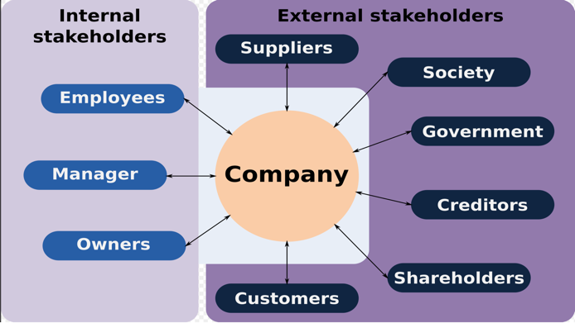

# Task 3: Develop support procedures

1. Describe one positive and one negative experience you have had when seeking assistance from a telecommunications company, an ISP or a computer supplier. Your experience may be via telephone, email or even voice recognition.

|  |  |  |
| --- | --- | --- |
| Type | Positive | Negative |
| Telephone | 1. Telephone communication has geographical reach 2. It can accessible nearly anytime if they have 7/11 customer service desk 3. Confidential if they don’t record the conversation 4. Potential quick response for trouble shooting | 1.Telephone communication can create uncertainty. This is because that it does not include body language and face expression  2.Might not hear well what they are speaking because of signal issue  3. Costly |
| Email | 1. Email has geographical reach 2. Email is accessible nearly anytime 3. Serves as a record and easier to track 4. Email is free | 1. Email might have security issues 2. Email can create uncertainty. This is because that it does not include body language, tone and other cues |
| Face to face | 1. Establish trust 2. Allows for easier persuasion 3. Provides clarity to communications | 1. Need to open schedule for a meeting 2. Need to use a transportation |
| Chat bot | 1. Geographical reach 2. Quick response for common issue 3. Free 4. 7/11 | 1. Cannot handle uncommon trouble 2. Some communication errors (detail and nuance etc) 3. This communication does not include body language, tone and other cues |
| Voice recognition | 1. Geographical reach 2. Can handle common issues immediately 3. Free 4. 7/11 | 1. Cannot handle uncommon trouble 2. AI does not understand tone and other cues 3. This communication does not include body language |

1. Using the experiences described above please answer the following questions.
   1. What support aspects were professional and/or unprofessional?
   2. How long did the support process take?
   3. Were the steps logical?
   4. Did they solve your problem?
   5. Was the call deflected to another area?

|  |  |  |
| --- | --- | --- |
| Items | Professional | Unprofessional |
| What support aspects were professional and/or unprofessional? | Attentive, Friendly | Some of customer service staffs do not have enough technical knowledge to deal with complicated issue |
| How long did the support process take? | Quick support via telephone | As above mentioned, some does not have advanced technical knowledge |
| Were the steps logical? | Yes. There are many options depending on what you need | No |
| Did they solve your problem? | Yes | No |
| Was the call deflected to another area? | Always on the same page | Will ask to put on veteran support staff if it deflects |

# Task 4: Assign Support Personnel

Classify the following into soft skills and technical skills. Your answer should take the form of a table shown below.

|  |  |  |
| --- | --- | --- |
| **Skill** | **Soft skill** | **Technical skill** |
| A knowledge of Linux | X | X |
| The ability to work under pressure | X | X |
| The administration of Windows 2008 Server | ○ | X |
| The ability to formulate network and IT policies | ○ | X |
| The ability to write network documentation | X | ○ |
| The ability to give presentations | ○ | X |
|  |  |  |

# Task 5: Short Answer Questions

1. Explain the relationship between data, information and knowledge.

The definition of data are individual measurements or facts. Information is some kind of model that describes or predicts implications from the data. Knowledge is how to get information from the data. This is about putting together the pieces.

Data information comes from outside sources, while knowledge is acquired by observation, experimentation, reasoning, inferring, and manipulating what is already known. Intelligence requires both to function efficiently. The more data/information/knowledge, the better the performance of intelligence.

Refer:https://steemit.com/information/@sajda/relationship-between-data-information-knowledge-and-intelligence

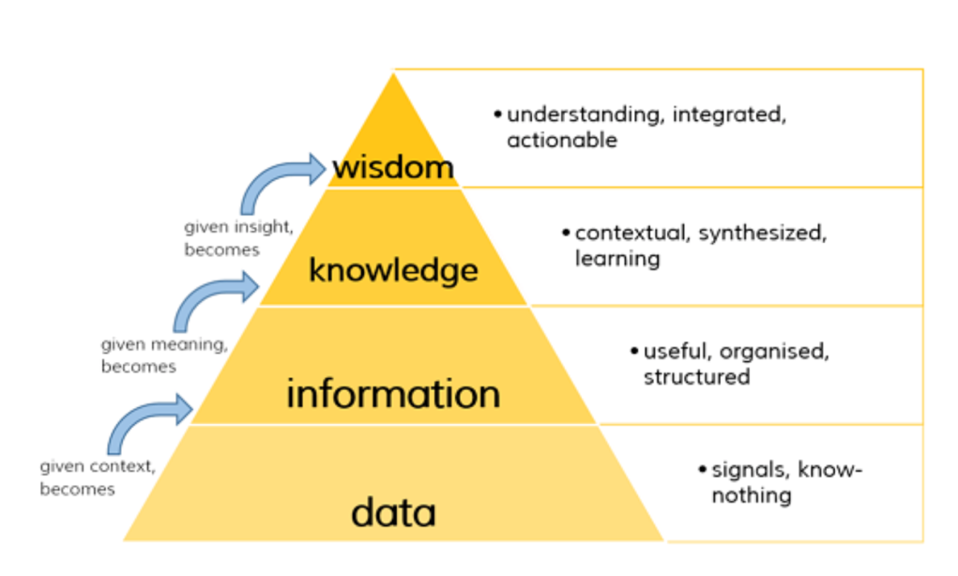

1. What is quantitative data and how can you use it.

Quantitative data is used when a researcher needs to quantify a problem, and answers questions like “what,” “how many,” and “how often.” This type of data is frequently used in math calculations, algorithms, or statistical analysis.

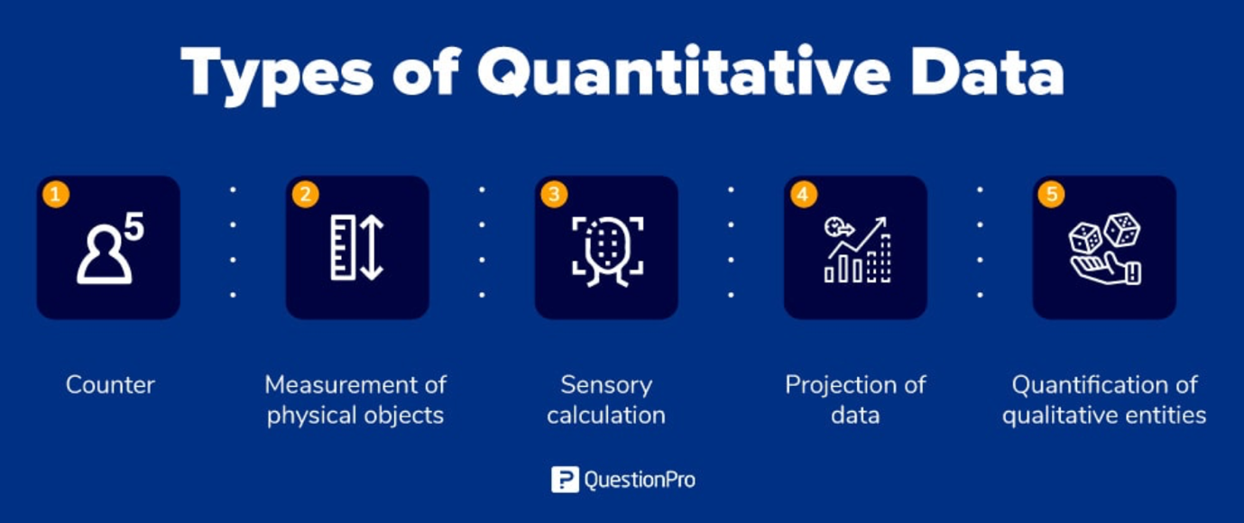Refer: https://www.questionpro.com/blog/quantitative-data/

1. What is qualitative data and how can you use it.

Qualitative data is the descriptive and conceptual findings collected through questionnaires, interviews, or observation. Analysing qualitative data allows us to explore ideas and further explain quantitative results.

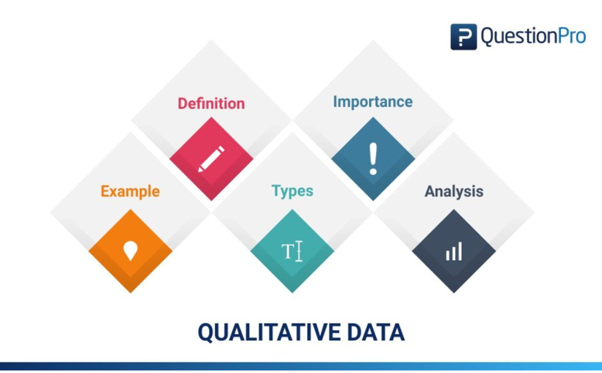

Refer: https://www.questionpro.com/blog/qualitative-data/

1. Give an example of how quantitative and qualitative data can be used in conjunction with each other

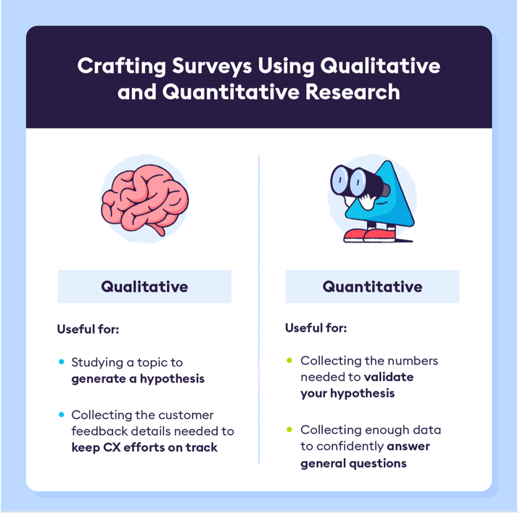

Qualitative data will generate a hypothesis and Quantitative data validate the hypnosis.

Quantitative research, like online surveys, tends to be more numbers-focused and can help to assess hypotheses from qualitative research. Adding a quantitative approach to qualitative research can provide a more holistic (and quantifiable) view of the subject matter you are researching.

Refer: https://www.cint.com/blog/using-both-qualitative-and-quantitative-approaches-in-your-research

Refer : https://chattermill.com/blog/qualitative-vs-quantitative-data/

1. What sort of methods could you use to determine client requirements for a website design and key information sources?

* 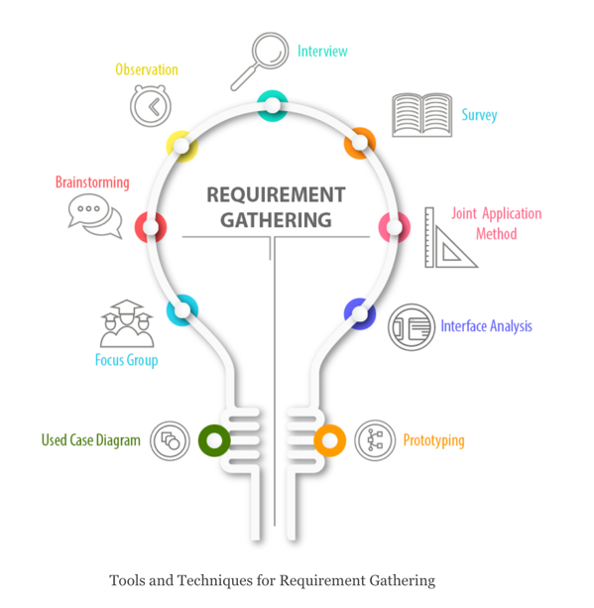An interview
* Questionnaire
* Focus group
* Structured workshop

Refer: https://nmgtechnologies.com/blog/requirement-gathering-solve-biggest-problems-consulting.html

1. 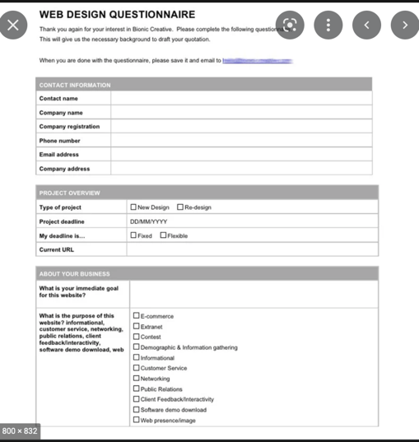Give some examples of client requirements for a website design

* Colour Scheme
* Fonts
* Logo design
* Images
* Favicon

Refer: https://www.primalspace.co.uk/client-requirements-website-design/

# Task 6: Multiple Choice Questions

1. 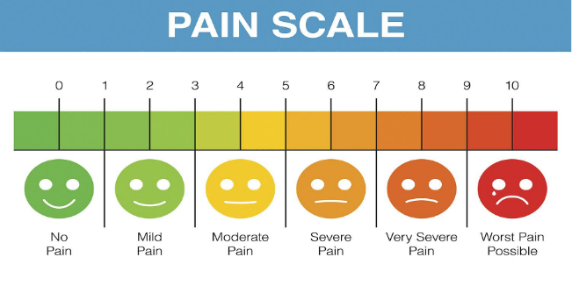Generally, how many points should a rating scale have?
   1. Five
   2. Four
   3. Ten
   4. Somewhere from 4 to 11 points

Comment

A rating scale is a closed-end survey question that is used to evaluate how survey responders feel about a particular product or statement.

Reference:

: <https://lumoa.me/blog/rating-scale>

1. 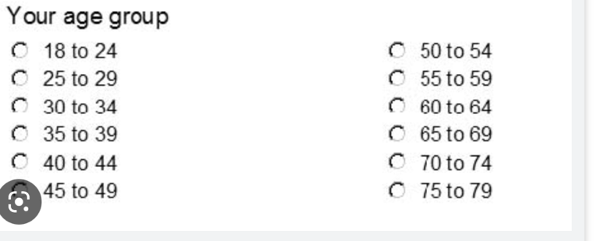What is the problem(s) with this set of response categories to the question “What is your current age?” o 1-5 o 5-10 o 10-20 o 20-30 o 30-40
   1. The categories are not mutually exclusive
   2. The categories are not exhaustive
   3. Both a and b are problems
   4. There is no problem with the above set of response categories

Comment: Age ranges are mutually exclusive and exhaustive.

Refer: https://www.cvent.com/en/blog/events/survey-response-design-mutually-exclusive-collectively-exhaustive-categories

1. You should mix methods in a way that provides complementary strengths and no overlapping weaknesses. This is known as the fundamental principle of mixed research.

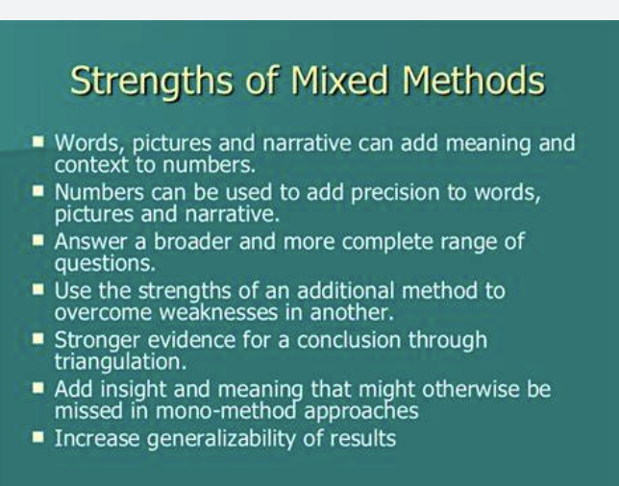a) True

b) False

Comment

Quantitative covers the weakness of qualitative and vice versa under mixed method

Refer: https://www.scribbr.com/methodology/mixed-methods-research/

1. According to the text, questionnaires can address events and characteristics taking place when?

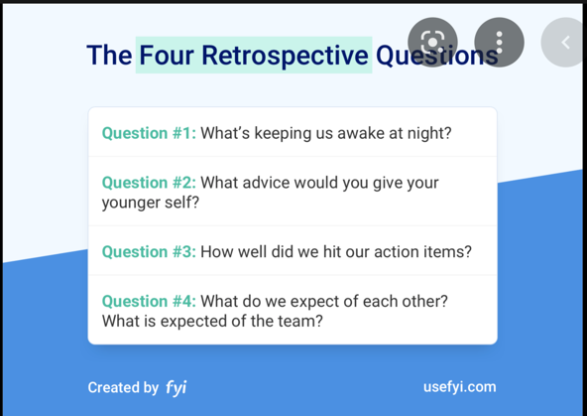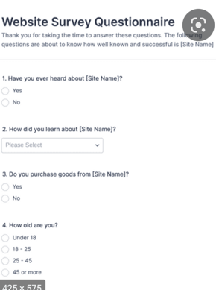

* 1. In the past (retrospective questions)
  2. In the present (current time questions)
  3. In the future (prospective questions)
  4. All of the above

Comment : See the right sample questionnaires have retrospective, current time and prospective questions

Refer https://www.jotform.com/form-templates/category/questionnaire

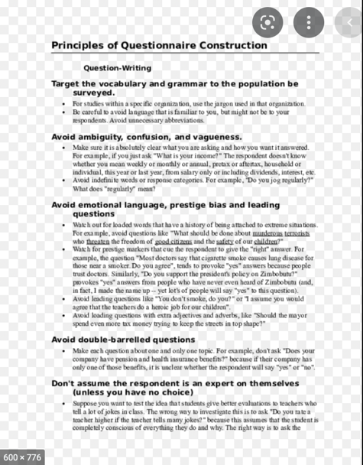

1. Which of the following are principles of questionnaire construction?
   1. Consider using multiple methods when measuring abstract constructs
   2. Use multiple items to measure abstract constructs
   3. Avoid double-barrelled questions
   4. All of the above e. Only b and c

Comment. See the right principles of questionnaire construction

Refer: https://www.academia.edu/14707822/Principles_of_Questionnaire_Construction_Question_Writing

1. Which of these is not a method of data collection?
   1. 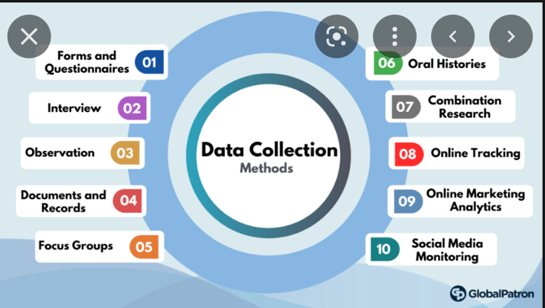Questionnaires
   2. Interviews
   3. Experiments
   4. Observations

Comment

Regarding to data-collection method, questionnaires, surveys, documents, and records are quantitative, while interviews, focus groups, observations, and oral histories are qualitative. There can also be crossover between the two methods

Refer https://www.globalpatron.com/blog/data-collection-methods/

1. Secondary/existing data may include which of the following?
   1. 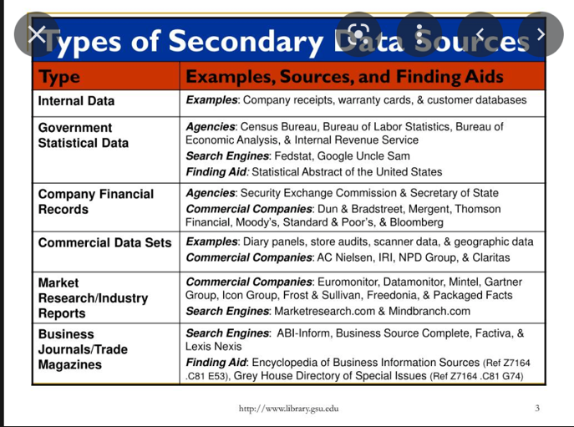Official documents
   2. Personal documents
   3. Archived research data
   4. All of the above

Comment Sources of secondary data include books, personal sources, journals, newspapers, websites, government records etc. Secondary data are known to be readily available compared to that of primary data. It requires very little research and needs for manpower to use these sources

Refer https://www.slideserve.com/Michelle/marketing-research

1. An item that directs participants to different follow-up questions depending on their response is called a ____________.
   1. 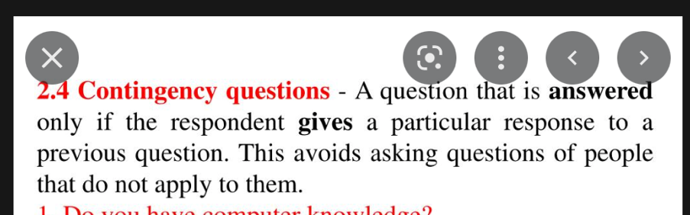Response set
   2. Probe
   3. Semantic differential
   4. Contingency question

Comment

Questions that are limited to a subset of respondents for whom they are relevant are called "contingency questions."

Refer

https://methods.sagepub.com/reference/encyclopedia-of-survey-research-methods/n99.xml

1. Which of the following terms best describes data that were originally collected at an earlier time by a different person for a different purpose?

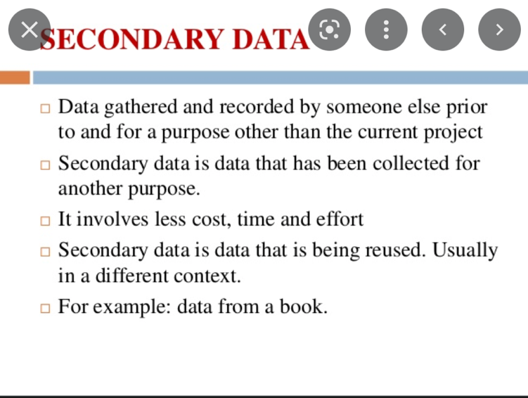a) Primary data

* 1. Secondary data
  2. Experimental data
  3. Field notes

Comment

Secondary data is the data that has already been collected through primary sources and made readily available for researchers to use for their own research

Refer

https://sites.google.com/a/eisth.org/computer-by-kru-ach-sn/type-of-data?tmpl=%2Fsystem%2Fapp%2Ftemplates%2Fprint%2F&showPrintDialog=1

1. Researchers use both open-ended and closed-ended questions to collect data. Which of the following statements is true?
   1. Open-ended questions directly provide quantitative data based on the researcher’s predetermined response categories
   2. Closed-ended questions provide quantitative data in the participant’s own words
   3. Open-ended questions provide qualitative data in the participant’s own words
   4. 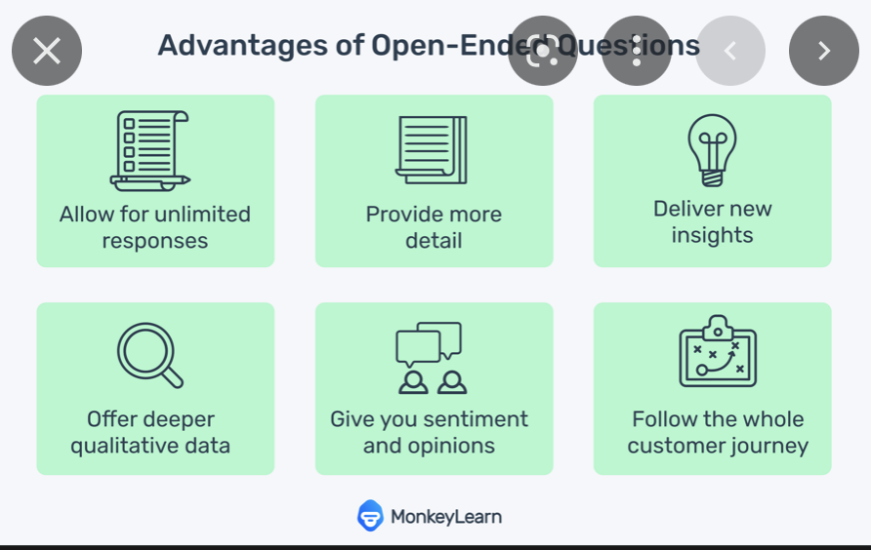Closed-ended questions directly provide qualitative data in the participants’ own words

Comment

Open-ended questions are questions that do not provide participants with a predetermined set of answer choices, instead allowing the participants to provide responses in their own words.

Refer

https://methods.sagepub.com/reference/the-sage-encyclopedia-of-communication-research-methods/i14345.xml

1. Open-ended questions provide primarily ______ data.
   1. Confirmatory data
   2. 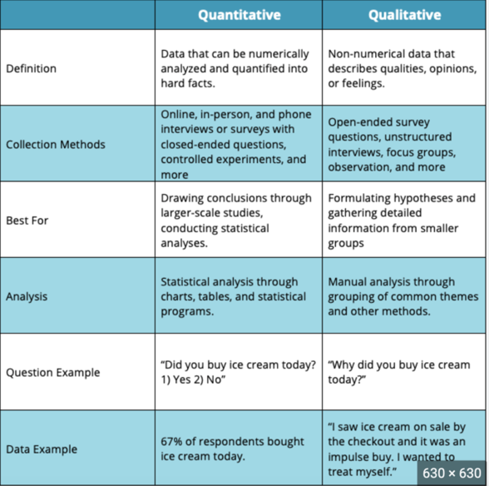Qualitative data
   3. Predictive data
   4. None of the above

Comment

A question in a survey for which there are no multiple options to choose from, with the respondent having to answer in their own words. Open-ended questions provide primarily qualitative data, and are generally used in exploratory research

Refer

https://www.pmlive.com/intelligence/healthcare_glossary/Terms/o/open_ended_question

1. Which of the following is true concerning observation?
   1. It takes less time than self-report approaches
   2. It costs less money than self-report approaches
   3. It is often not possible to determine exactly why the people behave as they do
   4. 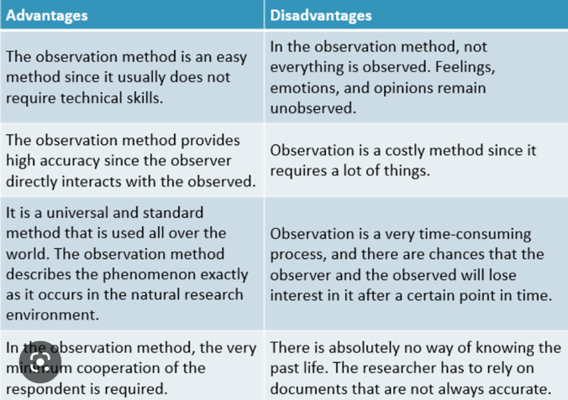All of the above

Comment

In the observation method, not everything is observed. Feelings, emotions, and opinions remain unobserved.

Refer

https://www.aplustopper.com/advantages-and-disadvantages-of-observation-method/

1. Qualitative observation is usually done for exploratory purposes; it is also called ___________ observation.
   1. 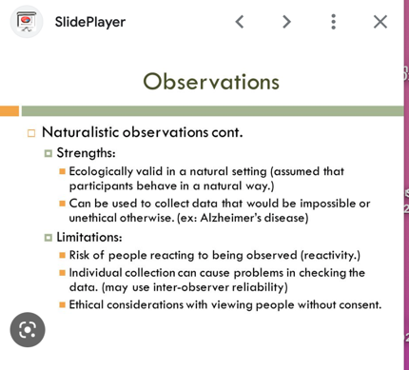Structured
   2. Naturalistic
   3. Complete
   4. Probed

Comment

Naturalistic observation is a qualitative research method where you record the behaviours of your research subjects in real world settings.

Reference:

https://www.scribbr.com/methodology/naturalistic-observation/

1. When constructing a questionnaire, it is important to do each of the following except ______.
   1. 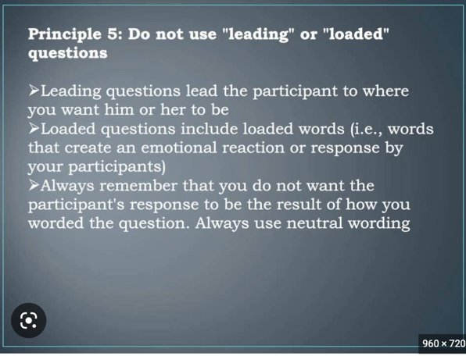Use "leading" or "loaded" questions
   2. Use natural language
   3. Understand your research participants
   4. Pilot your test questionnaire

Comment

Loaded questions are questions written in a way that forces the respondent into an answer that doesn't accurately reflect his or her opinion or situation.

Reference:

https://www.surveymonkey.com/mp/5-common-survey-mistakes-ruin-your-data/

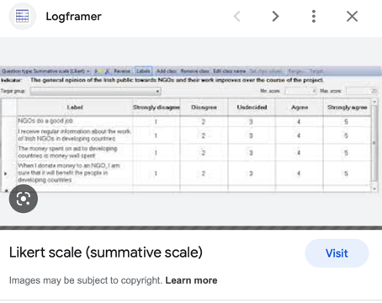

1. Another name for a Likert Scale is a(n):
   1. Interview protocol
   2. Event sampling
   3. Summated rating scale
   4. Ranking

Comment

Likert scales are often called summative scales.

Refer. https://en.wikipedia.org/wiki/Likert_scale

­­­­­­­­­­­­

1. Which of the following is not one of the six major methods of data collection that are used by educational researchers?
   1. Observation
   2. Interviews
   3. Questionnaires
   4. Checklists

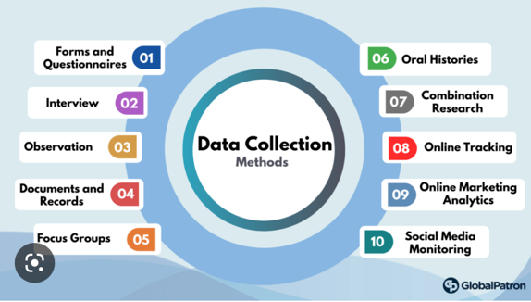

Comment

Six data collection methods

* Interviews.
* Questionnaires and surveys.
* Observations.
* Documents and records.
* Focus groups.
* Oral histories.

Reference:

https://www.jotform.com/data-collection-methods/

1. The type of interview in which the specific topics are decided in advance but the sequence and wording can be modified during the interview is called:

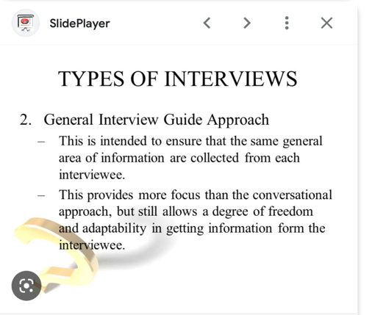a) The interview guide approach

* 1. The informal conversational interview
  2. A closed quantitative interview
  3. The standardized open-ended interview

Comment

The researcher usually develops an interview guide in advance to refer to during the interview (or memorizes in advance of the interview). An interview guide is a list of questions or topics that the interviewer hopes to cover during the course of an interview.

Reference

https://www.sciencedirect.com/topics/computer-science/interview-guide

1. Which one of the following in not a major method of data collection?
   1. 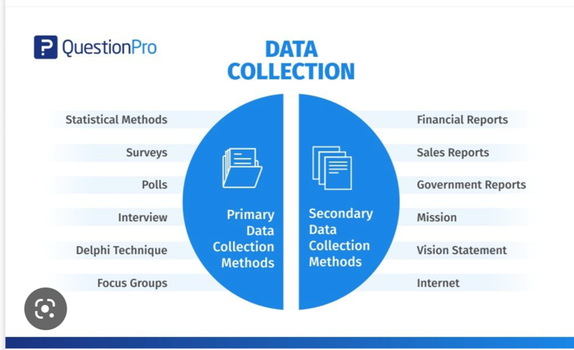Questionnaires
   2. Interviews
   3. Secondary data
   4. Focus groups
   5. All of the above are methods of data collection

Comment

See the picture at the right

Refer

https://www.questionpro.com/blog/data-collection-methods/

1. A question during an interview such as “Why do you feel that way?” is known as

a) Probe

* 1. 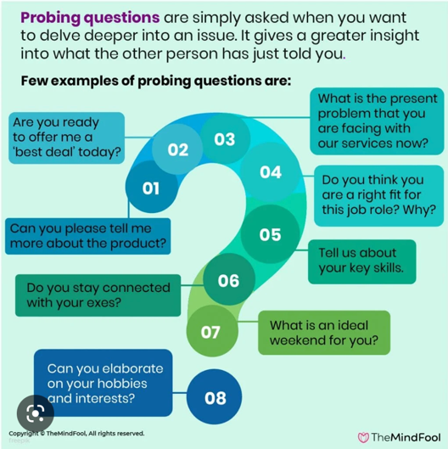Filter question
  2. Response
  3. Pilot

Comment

Probing questions are questions that you ask to gain greater insight into what someone has just told you, helping you to uncover the reasons and emotions behind what they have said.

Reference:

https://themindfool.com/different-types-of-probing-questions/

1. A census taker often collects data through which of the following?
   1. 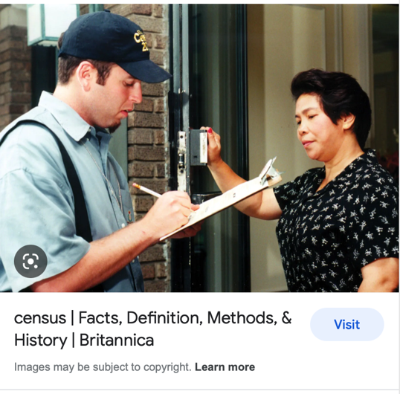Standardized tests
   2. Interviews
   3. Secondary data
   4. Observations

Comment

Census takers go on foot through their communities and take note of every housing unit they find.

Refer

https://www.britannica.com/science/census

1. The researcher has secretly placed him or herself (as a member) in the group that is being studied. This researcher may be which of the following?

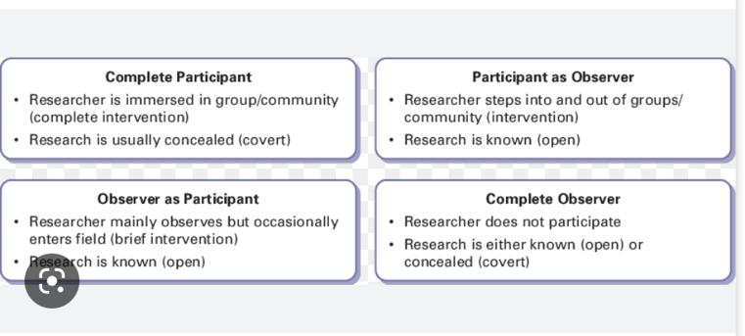a) A complete participant

* 1. An observer-as-participant
  2. A participant-as-observer
  3. None of the above

Comment

This is a fully embedded researcher, almost like a spy. Here the observer fully engages with the participants and partakes in their activities.

Reference

https://measuringu.com/observation-role/

1. Which of the following is not a major method of data collection?
   1. Questionnaires
   2. 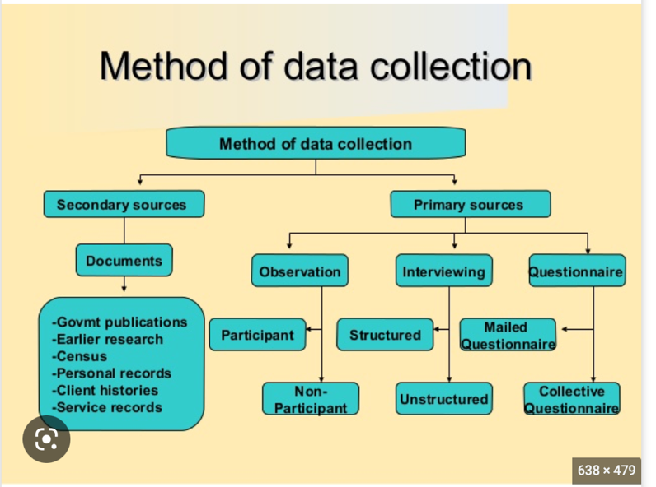Focus groups
   3. Correlational method
   4. Secondary data

Comment

See the right picture

Refer

https://library.up.ac.za/c.php?g=485435&p=4425506

1. Which type of interview allows the questions to emerge from the immediate context or course of things?

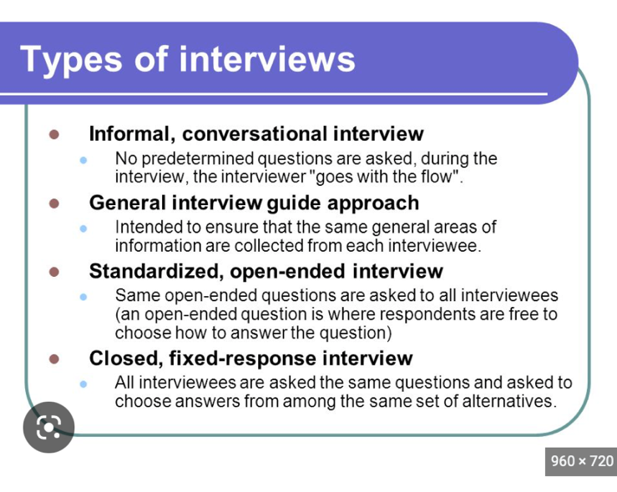a) Interview guide approach

* 1. Informal conversational interview
  2. Closed quantitative interview
  3. Standardized open-ended interview

Comment

Under conversational interviewing procedures, interviewers are allowed to ask respondents if they did not understand a question and provide unscripted feedback to clarify the meaning of questions as necessary.

Reference:

https://methods.sagepub.com/reference/encyclopedia-of-survey-research-methods/n107.xml

1. When conducting an interview, asking "Anything else? What do you mean? Why do you feel that way?," etc, are all forms of:
   1. 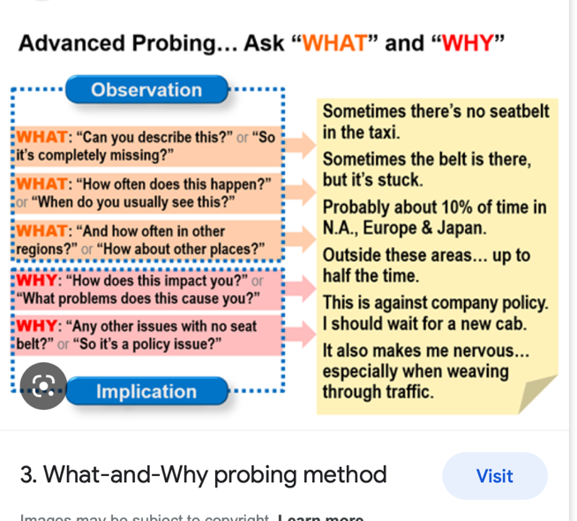Contingency questions
   2. Probes
   3. Protocols
   4. Response categories

Comment

Probing is asking follow-up questions when we do not fully understand a response, when answers are vague or ambiguous or when we want to obtain more specific or in-depth information.

Refer

https://fyi.extension.wisc.edu/programdevelopment/files/2016/04/Tipsheet34.pdf

1. 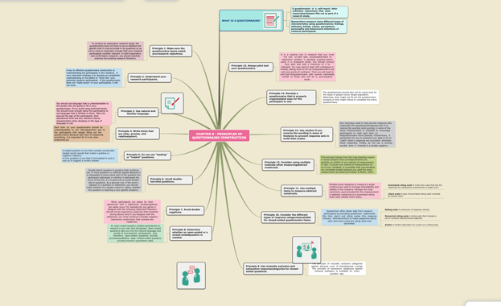When constructing a questionnaire, there are 15 principles to which you should adhere. Which of the following is not one of those principles?
   1. Do not use "leading" or "loaded" questions
   2. Avoid double-barrelled questions
   3. Avoid double negatives
   4. Avoid using multiple items to measure a single construct

Comment

See the right picture

Reference:

https://www.mindomo.com/sv/mindmap/chapter-8-principles-of-questionnaire-construction-e8a69f6fa9b34accb4580a173227dd7c

1. A customer-based Service Level Agreement structure includes:
   1. An SLA covering all Customer groups and all the services they use
   2. SLAs for each service that are Customer-focused and written in business language
   3. An SLA for each service type, covering all those Customer groups that use that Service
   4. An SLA with each individual Customer group, covering all of the services they use

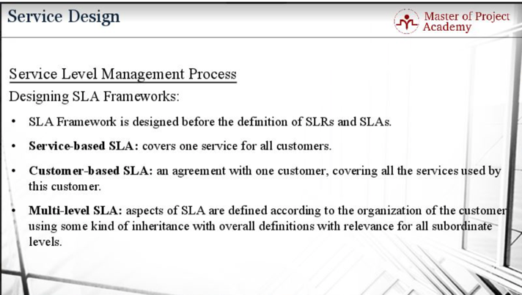

Comment

A customer-based SLA is between an individual customer or a group of customers and a service provider.

Reference:

https://blog.masterofproject.com/3-types-sla/

1. Which of the following best describes the goal of Service Level Management?
   1. To maintain and improve IT service quality in line with business requirements
   2. To provide IT services at the lowest possible cost by agreeing with Customers their minimum requirements for service availability and ensuring performance does not exceed these targets
   3. To provide the highest possible level of service to Customers and continuously improve on this through ensuring all services operate at maximum availability
   4. To ensure that IT delivers the same standard of service at the least cost

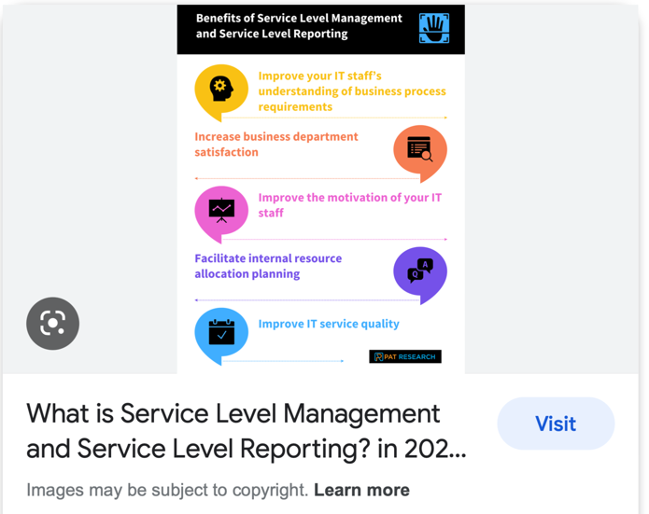

Comment

The purpose of the SLM practice is to set clear business-based targets for service performance, so that the delivery of a service can be properly assessed, monitored, and managed against these targets.

Refer

https://www.bmc.com/blogs/itil-service-level-management/

1. The process to implement SLAs comprises of the following activities in sequence:
   1. Draft SLAs, catalogue services, review underpinning contracts and OLAs, draft SLRs, negotiate, agree

SLAs

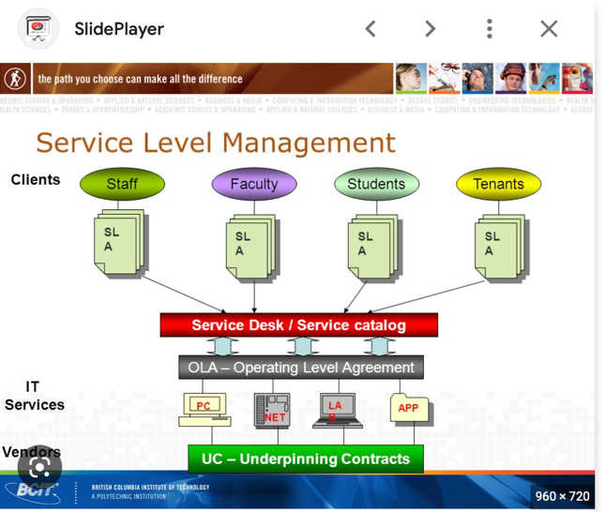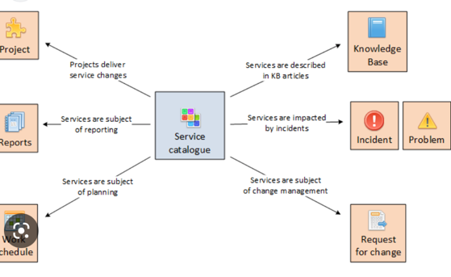

* 1. Draft SLAs, review underpinning contracts and OLAs, negotiate, catalogue services,
  2. Review underpinning contracts and OLAs, draft SLAs, catalogue services, negotiate, agree SLAs
  3. Catalogue services, establish SLRs, review underpinning contracts and OLAs, negotiate service levels, agree SLAs

Comment

This entity is used for particular services. Key attributes are name, description, status, service classification and criticality, supported processes, business owners and users, IT owners, SLA, supporting OLA and contracts, costs and other financial aspects of services, metrics and used strategy

Reference:

https://www.objectgears.eu/service-catalogue#knowledge-management-en

1. Which of the following is an example of a service level agreement (SLA) between information systems support unit and a research unit in the laboratories of a large company?
   1. The maximum response time to get the system operational should it fail.
   2. The minimum ‘up-time’.
   3. The types of information that will be provided as standard.
   4. All of the above.

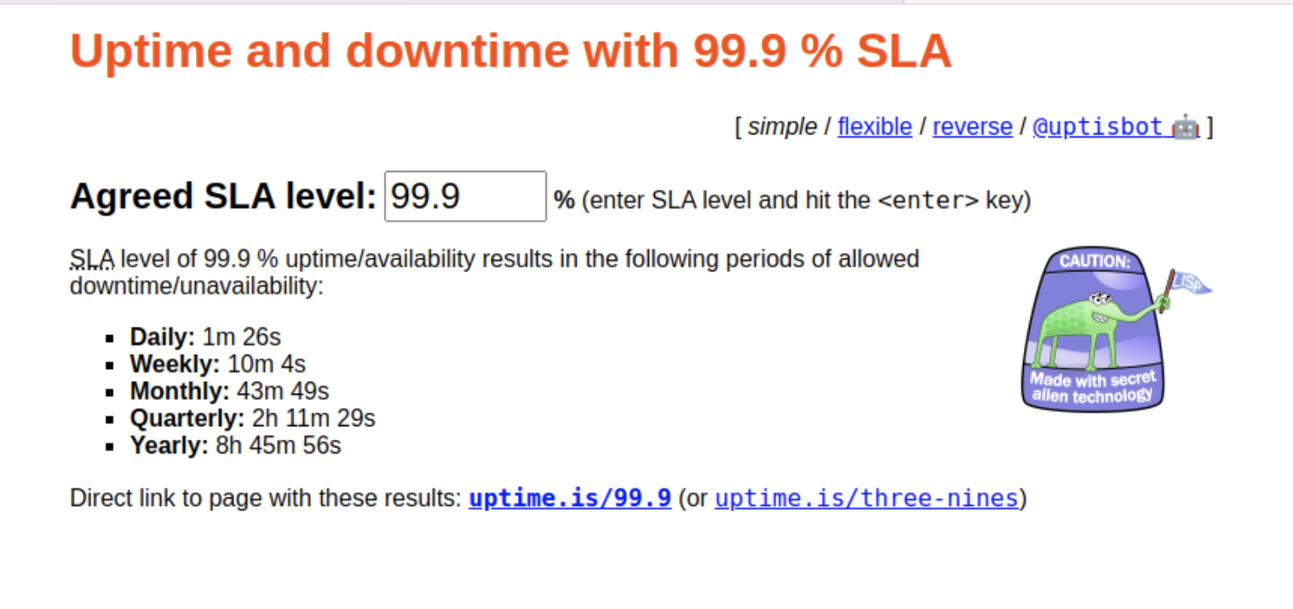

Comment

A service-level agreement (SLA) defines the level of service expected by a customer from a supplier, laying out the metrics by which that service is measured, and the remedies or penalties, if any, should the agreed-on service levels not be achieved. Usually, SLAs are between companies and external suppliers, but they may also be between two departments within a company.

A telecom company’s SLA, for example, may promise network availability of 99.999 percent (for the mathematically disinclined, that works out to about five and a quarter minutes of downtime per year, which, believe it or not, can still be too long for some businesses), and allow the customer to reduce their payment by a given percentage if that is not achieved, usually on a sliding scale based on the magnitude of the breach.

Service elements include specifics of services provided (and what’s excluded, if there’s room for doubt), conditions of service availability, standards such as time window for each level of service (prime time and non-prime time may have different service levels, for example), responsibilities of each party, escalation procedures, and cost/service trade-offs.

Management elements should include definitions of measurement standards and methods, reporting processes, contents and frequency, a dispute resolution process, an indemnification clause protecting the customer from third-party litigation resulting from service level breaches (this should already be covered in the contract, however), and a mechanism for updating the agreement as required.

Refer

https://www.cio.com/article/274740/outsourcing-sla-definitions-and-solutions.html

1. Some organisations bring a degree of formality to the internal customer concept by encouraging (or requiring) different parts of the operation to agree on:

a) Internal service agreements

* 1. Service level agreements
  2. 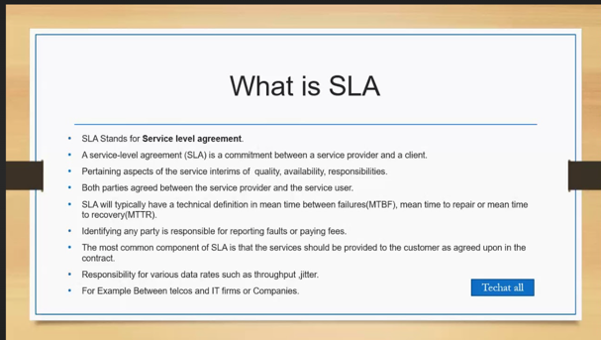Formal provision agreements
  3. Delivery agreements

Comment

The SLA describes in detail the terms of service and the responsibilities of the customer and service provider

Reference:

https://elearning.wic.nsw.edu.au/pluginfile.php/41676/mod_resource/content/1/Learners_%20Guide_Evaluate%20and%20Communicate%20Business%20Requirements.pdf

# Search Index

Contingency question, 15

Linux server, 2, 4

mix methods, 13

Service Level Agreement, 25

Service Level Management, 25